Agenda

NeASFAA Annual Association Meeting

Thursday April 16th

Kearney, NE – Kearney Holiday Inn

Call to Order

1. Approval of Agenda
2. Approval of minutes from April 2013 Association Business Meeting
3. Approval of minutes from April 2014 Association Business Meeting
4. Continued Business
5. New Business
6. Action Item 1 – Change to Standing Committees
7. Action Item 2 – Officer Committee References
8. Action Item 3 – Board Designated Committees
9. Action Item 4 – Board Authority
10. Action Item 5 – Word and Phrase Corrections
11. Budget Presentation
12. Announcement of New Officers & Committee Chairs
13. Officer Reports
14. President, Matt Johnson
15. President Elect, Kay Dinkelman
16. Past President, Tom Ochsner
17. Treasurer, Marty Habrock
18. Secretary, Bailey Jorgensen
19. Historian Report
20. Sector Representative Reports
21. Private Career, Andrew Landrum – no report
22. Two-year Public Institutions, Stacy Dieckman
23. Private Colleges and Universities, Wendy Matulka
24. Four-year Public Colleges and Universities, Erin Moran – no report
25. Associate Membership, Stacy Seim – no report
26. Committee Reports
27. State Legislation Task Force update, Stacy Dieckman
28. Professional Development Committee, Mary Sommers
29. Nominations and Elections, Kay Dinkelman
30. Membership, Shareen Thewke
31. Finance and Audit, Hylee Asche
32. Corporate Development, Stacy Seim
33. Communications, Linda Butcher
34. Awards, Sara Bennett
35. Association Governance, Tom Ochsner
36. Adjournment

**April 26 2013 NeASFAA Annual Business Meeting Minutes**

The meeting was called to order by Tom Ochsner at 8:35.

Tom called to for a motion to approve the agenda. Vicki Kucera moved to have the Agenda approved. Hylee Asche seconded the motion. The agenda was approved.

Minutes from the last year’s board meeting had been distributed by NeASFAA secretary Matt Johnson for review by the membership. Tom called for any revisions or additions and none were noted. Doug Watson moved to approve the minutes. Kyle Rose seconded the motion. The minutes were approved.

Officer Reports

President – Tom Ochsner: Verbal Report stated that it had been a wonderful conference and thanked the PDC for their hard work putting together the conference. He reported that he last attended the RMASFAA board meeting on March 1st and 2nd and felt that much had been accomplished at this meeting with the leadership of RMASFAA president Jeff Jacobs. He thanked the association of the opportunity to serve as president and the board for working with him over the past year.

Past President – Peggy Tvrdy: No Report

President Elect— LeAnn Hoffman: Verbal Report. LeAnn reports that she is excited about this next year working for NeASFAA and with the new board. She reported that elections were held successfully with a full slate of nominees. LeAnn attended the NASFAA leadership conference and expressed what an awesome opportunity it was to be able to go. She stated that this conference is a very positive experience for the person who is elected president elect and well worth the association financing of the conference for this person. She thanked the association for investing in and sending her. She also put out a passionate request for nominations to committees, asking that the members fill out the forms and take the opportunity to serve in NeASFAA.

Treasurer – Marty Habrock: Verbal Report. Marty had distributed balance sheets to the members for their review. He reports that FES continues to provide $1,500 in funding to support the SOCs website licensing and thanks them for this support. He reported that with Finance and Audit Committee’s and board’s recommendation that the CDs be reorganized such that instead of several small CDs that they be organized into four approximately equal valued CD’s that mature quarterly. The checking account and balance is healthy and no reserves have been used to supplement the checking account for at least the last 4 years. It would not appear that there is any need to tap reserves this year either.

Secretary – Matt Johnson: He reports that minutes were kept and approved throughout the year. As president elect elect he encouraged volunteering for positions as a way to better know the association and those who are a part of it. He emphasized that this is a wonderful opportunity to build your leadership skills by being a part of the board and committees.

Private Career – Sarah Christensen: Sarah reports that she is continuing to brainstorm ideas for the sake of increasing participation in NeASFAA within her sector.

Two Year Public Institutions – Hylee Asche: Hylee reports that her sector met with and discussed the Davis Chambers scholarship.

Private Colleges and Universities – Annie Lee: She reports that she will be the sector rep for one more year of her term. (Annie recently was appointed to this position to fill this position.)

Four Year Public – Matt Petr: Matt reports that his term as sector rep will be expiring at this time and that Erin Moran is taking over this position. One of the agenda items that came up for board approval during this year was that the board support individuals in the RMASFAA Pipeline leadership training with paying for up to $500 in expenses to attend the RMASFAA conference as required in this training. This was approved. He reports that the discussion in the sector meeting from the day before centered around the Unusual Enrollment Flags and PLUS processes.

Associate Sector & Corporate Development Committee– Don Buehrer: Reports that in conjunction with the membership committee that they are working together to streamline the billing to associate members to clarify and combine the payment of membership fees and exhibit/sponsorship payment. Don reports that we had 11 venders this year compared to 7 last year.

Committee Reports:

Association Governance – Ritchie Morrow: Ritchie is reporting for Peggy Tvrdy. The board had charged this committee to look at 5 issues. The committee met twice to discuss these issues. Four of the issues dealt with Membership fees issues and late fees issues. The work on these points was meant to streamline membership and fees for the associate sector. It ended up having implications for the billing cycle for the association. The committee also looked at the awards structure some to determine if anything should be done to make awards more inclusive of the business officers.

Awards Committee – Becca Dobry: Becca continues to encourage nominations be made through the year. She will be the awards chair this next year also since she took over when the chair left. She also asks that other award news like baby births be passed along to her so these can be announced. Otherwise the awards were made for this past year.

Communications – Tom Ochsner: Tom is reporting for Lani Swanson. Tom reminded the association that we do have a Facebook page and he encourage that we friend this page. Communications is working to continue to refresh the web page. He asks that we continue to make updates to the NeASFAA directory online and to include business officers on the directory and have them sign up for the Listserv so that they can collaborate using this tool as well.

Finance and Audit – Tom Ochsner: Tom reports for this committee that went through several chair and membership changes this cycle. The audit was completed in October. The committee had no findings. The committee had made some recommendations on managing NeASFAA’s reserves to the treasurer and Marty has begun to implement some of those recommendations as indicated in his report.

Membership – Lisa Gdowski: Lisa reports that the membership listing has been recently updated with all of the changes that she was made aware of and so at this point it is current. She reports that we have 33 paid Institutional members and 12 paid Associate members. Two new associate member applications were approved this last year. She reported on changes to policy approved at the last board meeting. At the top of June the first billing for renewed membership will go out. A reminder will be sent the top of July if payment has not yet been made and then by September 1st a statement will go out with a $50 late charge affixed.

Nominations and Elections – LeAnn Hoffman: Reports elections were held with full ballots.

Professional Development Committee – Laura Schultz: Laura thanked everyone for coming to the conference and helping make it a success. She thanked the board for its direction and support. She also thanked all of the speakers for presenting at the conference. She announced that the next conference will be held in Norfolk at the Divots conference center, April 10th and 11th. She asks that people let her know what their ideas are for improvements and asks that the evaluations be turned in. She reminded the Business folks in attendance that there will be a Federal Perkins Update session for them.

Old Business: None

New Business:

Approval of the 2013/2013 budget. It was noted that the new budget was a little leaner than perhaps in prior years. Actual expenditures were provided to the board members and committees so that they could see what was actually used in the last three years. The goal of this was to help them evaluate whether they were using what was budgeted, or if there may be more budgeted than was necessary. In this way we can put together a better budget. We have been under budget for several years. Also as has been the case for several years, a special note was made about the budgetary line item for the FES assistance provided for our web service as it relates to the budget.

There was some discussion requesting clarification on the amount of reserve that the association needed to keep. It was explained that we needed a minimum of 50% of the operating budget in reserve. We have significantly more than this.

Terri Graham moved to approve the budget. Lisa Gdowski seconded the motion. The motion carried.

There was no additional new business.

LeAnn Hoffman moved to adjourn. Dale Brown seconded the motion. The meeting was adjourned.

**NeASFAA Business Meeting Minutes**

**April 11, 2014, Norfolk, Divots Conference Center**

Call to order at 9:23 AM. 15 voting members in attendance, quorum not established

1. Approval of Agenda-No quorum to approve
2. Approval of minutes from Jan 2014-Since quorum is not established at this meeting, minute approval will be voted on via email.
3. Officer Reports
   1. President, Matt Johnson-Written report attached. Became president when LeAnn Hoffman vacated position due to taking a job in another state. Matt called again for volunteers and emphasized not only the importance of volunteering on the association, but also the personal and professional growth that comes out of NeASFAA involvement.

Attended RMASFAA conference.

Acknowledged the board’s work and especially the work on the strategic directions document.

* + 1. President elect-Announced board members for 2014-15.
    2. Nominations and elections
  1. Past President, Tom Ochsner-Written report attached under Association Governance Report
  2. Treasurer, Marty Habrock-Written report attached

Consolidated CD’s so that they come due on a regular basis, quarterly

Balance sheet attached-income for conference shows currently, but not expenses yet

Profit and loss statement attached

SOCS website service provided free of charge rather than providing offsetting grant this year.

* 1. Secretary, Beth Sisk-Written report attached

1. Committee Reports
   1. Association governance, Tom Ochsner-Written report attached
   2. Awards, Becca Dobry-Written report attached. Provided awards nomination sheets here at spring conference for next year’s nominations
   3. Communications, Mary Lohse & Lani Swanson-Written report attached. Attended free SOCS training and found out more about web capabilities. Now using Drop Box where members can post documents in the box, under the forms page. Can drop pictures in the box to share and communications committee monitors this. Our website template will be updated by SOCS free of charge. Listserv: trying to get it updated and to get as many members signed up as possible. Communications committee would like you input to keep the website as up to date as possible.
   4. Corporate Development, Don Buehrer-Don reached out quite a bit to the associate sector. Worked on getting conference registration/sponsorship/exhibiting/membership as smooth as possible for the sector.
   5. Finance and Audit, Renee Besse-Written report attached. Reviewed audit guide, the P&P, insurance policy, accounting software for accuracy and updated where needed. Strategic fiscal plan. The budget was approved by the board.
   6. Membership, Andrea Quimbly-Written report attached.
   7. Professional Development, Laura Schultz & Ritchie Morrow-Written report attached. Member recognition. Support staff workshop very successful, great attendance, great training. Fall training offered in two locations. More than 150 people trained in all three sessions.
2. Sector Representatives
   1. Associate Membership, Don Buehrer-No further written report from corporate development report.
   2. Private Career, Sara Christensen- Written report attached. Discussion from sector meeting: 1st proposal: like this idea, 2nd proposal: have award chair on PDC, not entire committee, 3rd proposal: Like current structure as it is.
   3. Two-year public institutions, Stacy Dieckman-Written report attached. Discussion from sector meeting: 1st proposal: like this idea, 2nd proposal: concern about sector reps also on PDC, 3rd proposal: like this idea where committees could change based on needs.
   4. Private Colleges and Universities, Wendy Matulka- Written report attached. Discussion from sector meeting: 1st proposal: like this idea, 2nd proposal: need further clarification, 3rd proposal: liked this idea. Annie Lee resigned her position due to taking a job out of state.
   5. Four-year public Colleges and Universities, Erin Moran-Written report attached. Discussion from sector meeting: 1st proposal: like this idea, 2nd proposal: PDC absorb awards and add responsibilities for awards to PDC, 3rd proposal: like this idea.
3. New Business
   1. Further discussion on the reordering of our committee structure-discussed earlier
      1. Assoc. Governance findings
      2. Bylaw implications
      3. P&P implications
   2. 2014-2015 Budget Approval
   3. Strategic Directions discussion-Document started in June 2013 meeting. Final board-approved document is posted on NeASFAA website under the Board of Director’s site. Short term document, covering through 2016. Based on NeASFAA bylaws. Some items are already working and in place, some will be in the future. This document was worked on in the board meetings and has been discussed in each meeting this year, will be used in future board meetings for direction. Please provide feedback to Matt or through sector reps.
4. Adjournment at 10:06 AM

**Action Item #1 – Change to Standing Committees**

**Justification**

The board felt that listing specific committees in the Bylaws limits the ability to make adjustments to the committee structure of the Association based on current needs. Using more generic text, allows the current Board to make adjustments on an as-needed basis by amending the Policies and Procedures Manual by a vote of the Board.

**Old Language**

# ARTICLE VII: STANDING COMMITTEES

Section 1. Finance & Audit Committee The Finance & Audit committee shall, at the annual meeting of the Corporation, recommend an Association budget for the ensuing year. The Committee is responsible for maintaining the fiscal integrity of the Corporation and shall review the financial records of the Association and submit a report at the annual meeting.

Section 2. Association Governance Committee The Association Governance committee is responsible for reviewing the operating documents of the Corporation and recommending necessary corrections and revisions to the membership of the Corporation.

Section 3. Communications Committee The Communications committee is responsible for coordinating the distribution of all general publications, regardless of media used, to the membership.

Section 4. Corporate Development Committee The Corporate Development committee is responsible for soliciting all funds to support the purposes of the Association, except for the collection of membership dues.

Section 5. Membership Committee The Membership committee is responsible for the cultivation of new and retention of current members to the Association.

Section 6. Nominations & Election Committee The Nominations & Election committee is responsible for the cultivation and nomination of eligible members of the Corporation's Board of Directors and other regional and/or national offices within the financial aid association realm, and for conducting the election process within the Corporation.

Section 7. Professional Development Committee The Professional Development committee is responsible for developing, planning, coordinating and actualizing all training activities to the members of the Corporation and such outreach programs to entities and persons not a Corporation member as may be approved by the Corporation or Board of Directors.

Section 8. Awards Committee The Awards committee is responsible for recognizing and honoring individuals who are NeASFAA members and have contributed to NeASFAA’s mission.

SPECIAL COMMITTEES Section 1. Ad Hoc Ad Hoc committees may be created to carry out specific and necessary functions of the Corporation. The President is responsible, subject to Board of Directors approval, for the creation of such a committee which shall address the specific purpose, the scope, authorized time limit and membership composition.

**New Language**

# ARTICLE VII: COMMITTEES

Standing and special committees may be created to promote the purposes of the Association or to carry out necessary functions of the Association. Creation of such committees, their jurisdiction, the number, and the selection and tenure of their members shall be the responsibility of the President, subject to the approval of the Board of Directors.

**Action Item #2 – Officer Committee References**

**Justification**

Assuming action item #1 is approved by the membership, Action Item #2 will amend Article 6 Sections 6-10 to remove specific references to specific Board members’ committee assignments. Additionally, the descriptions of the officer duties were reviewed to remove overly prescriptive language that is best managed in the policies and procedures and leaving descriptions of duties that should always be true of the office.

**Old Language**

Section 6. President The President shall be the chief executive officer of the Association , preside at all meetings of the Association and be Chairperson and preside at all meetings of the Board of Directors. The President shall appoint, from the Corporation's membership, the members and Chairmen and be an ex-officio member of all non-Board of Directors committees. The President shall attend all meetings of the members and the Board of Directors and present a final report to the membership at the annual meeting at the end of the term of office. The President may sign, with the Secretary or any other proper officer of the Corporation authorized by the Board of Directors, any contracts or other instruments which the Board of Directors has authorized to be executed, except in cases where the signing and execution thereof shall be expressly delegated by the Board of Directors or by these Bylaws or by statue to some other officer or agent of the Corporation; and in general perform all duties incident to the office of President and such other duties as may be prescribed by the Board of Directors. The President is directly responsible of overseeing and coordinating the functions of the Finance & Audit and Corporate Development committees. The President also serves as the voting representative of NeASFAA on the Rocky Mountain Association of Student Financial Aid Administrators Board of Directors.

Section 7. President-Elect The President-Elect shall automatically become President of the Association at the end of the term of office of President-Elect. The President-Elect shall perform the duties of the President in the absence of or incapacity of the President. The President-Elect shall present a final report of the office to the membership at the annual meeting. The President-Elect is directly responsible for overseeing and coordinating the function of the Professional Development and the Nominations & Election committees. The President-Elect may serve as an observer at the RMASFFA Board of Directors and will normally attend the Leadership Conference sponsored by the National Association of Student Financial Aid Administrators (NASFAA).

Section 8. Secretary The Secretary shall be responsible for keeping and maintaining the records of the Association and the Board of Directors, for the mailing of meeting notices and other such communication as provided for by law or in the Bylaws, and for the performances of other such duties as may be prescribed by the Board of Directors. The Secretary shall be the custodian of the corporate records and of the seal of the Corporation and see that the seal of the Corporation is affixed to all documents, the execution of which on behalf of the Corporation under its seal is duly authorized in accordance with the provisions of these Bylaws; keep register of the post office address of each member and each Director; and in general perform all duties incident to the office of Secretary and such other duties as may be assigned by the President or by the Board of Directors. This office is responsible for overseeing and coordinating the function of the Communications and Membership committees.

Section 9. Treasurer The Treasurer shall be responsible for the receipt and expenditure of funds in accordance with the directives established by the Board of Directors. The Treasurer shall maintain appropriate and adequate financial records, shall submit all records for a duly audited annual financial report conducted by such persons, committee or agency as determined by the Board of Directors and shall be under such bond as determined by the Board of Directors. Upon termination of the term of office, the Treasurer shall transfer to the successor all moneys and financial records.

Section 10. Past-President The Past-President serves the Board of Directors by providing continuity and insight on prior Board of Director activities and actions. In the absence of the President and President-Elect, this office will serve as chairman of the Board of Directors and preside at the annual meeting of the Corporation. The Past-President is directly responsible for overseeing and coordinating the functions of the Association Governance committee. The Past-President may also lead any long range planning as authorized by the Board of Directors.

**New Language**

**Section 6. President** The President shall be the chief executive officer of the Association , preside at all meetings of the Association and be Chairperson and preside at all meetings of the Board of Directors. The President shall attend all meetings of the members and the Board of Directors. The President may sign, with any other proper officer of the Corporation authorized by the Board of Directors, any contracts or other instruments which the Board of Directors has authorized to be executed, except in cases where the signing and execution thereof shall be expressly delegated by the Board of Directors or by these Bylaws or by statute to some other officer or agent of the Corporation; and in general perform all duties incident to the office of President and such other duties as may be prescribed by the Board of Directors.

**Section 7. President-Elect** The President-Elect shall automatically become President of the Association at the end of the term of office of President-Elect. The President-Elect shall perform the duties of the President in the absence of or incapacity of the President.

**Section 8. Secretary** The Secretary shall be responsible for keeping and maintaining the records of the Association and the Board of Directors, and perform other duties as may be prescribed by the Board of Directors.

**Section 9. Treasurer** The Treasurer shall be responsible for the receipt and expenditure of funds in accordance with the directives established by the Board of Directors. The Treasurer shall maintain appropriate and adequate financial records, shall submit all records for a duly audited annual financial report conducted by such persons, committee or agency as determined by the Board of Directors and shall be under such bond as determined by the Board of Directors. Upon termination of the term of office, the Treasurer shall transfer to the successor all moneys and financial records.

**Section 10. Past-President** The Past-President serves the Board of Directors by providing continuity and insight on prior Board of Director activities and actions. In the absence of the President and President-Elect, this office will serve as chairman of the Board of Directors and preside at the annual meeting of the Corporation.

**Action Item #3 – Board Designated Committees**

**Justification**

The Board felt that, now that Association business can be discussed and voted on through email, Article V, Section 15 is no longer needed to create a special committee with Board of Directors powers. The other language describing committee appointments, members and duration is best left to the policies and procedures.

**Old Language**

## Section 15. Organization

* The Board of Directors may designate one or more committees which shall consist of two (2) or more Directors elected by the Board of Directors which may exercise, when the Board of Directors is not in session, the powers of the Board of Directors in the management of the affairs of the Corporation. However, no such committee shall have the authority of the Board of Directors in reference to amending, altering or repealing the Bylaws; electing, appointing or removing any member of any committee or any Director or Officer of the Corporation; amending the Articles of Incorporation; adopting a plan or merger or adopting a plan of consolidation with another corporation; authoring the sale, lease, exchange or mortgage of all or substantially all of the property and assets of the Corporation; authorizing the voluntary dissolution of the Corporation or revoking proceedings; adopting a plan for the distribution of the assets of the Corporation; or amending, altering or appealing any resolution of the Board of Directors which by its terms provides that it shall not be amended, altered or appealed by such committee. The designation and appointment of any such committee and the delegation of authority shall not operate to relieve the Board of Directors, or any individual Director of any responsibility imposed upon it or him by law.
* Other committees not having the authority of the Board of Directors in the management of the Corporation may be designated by a resolution by a majority of the Directors present at a meeting at which a quorum is present. Except as otherwise provided in such resolution, members of each committee shall be appointed by the President. Any member may be removed by the person(s) authorized to appoint such member whenever in their judgement the best interests of the Corporation shall be served by such removal.
* Each member of a committee shall continue as such until the next annual meeting of the Board of Directors and until his successor is appointed, unless the committee shall be terminated sooner, or unless such member be removed from such committee, or unless such member shall cease to qualify as a member.

**New Language**

*None…section completely stricken

**Action Item #4 – Board Authority**

**Justification**

The board felt that having taken out language referring to a committee that once could be formed to act on behalf of the Board, it would be prudent to beef up this languages making the role of the board clear as the sole body that conducts the association business. In other words, no committee, no other body, can be granted the powers held by the board. This builds on our prior action item where at one time creating such a committee may have introduced an efficiency necessary to conduct board/association business. Now with high speed email and other communications, granting such a power to a committee is not required. An astute observer will see that much of this language has been borrowed from NASFAA bylaws.

**Old Language**

**ARTICLE V: BOARD OF DIRECTORS**  
**Section 1. Powers** Subject to the limitations of the Articles of Incorporation of the Corporation, the Bylaws and the laws of the State of Nebraska, the affairs of the Corporation shall be managed by the Board of Directors.

**New Language**

**ARTICLE V: BOARD OF DIRECTORS**  
**Section 1. Powers** Subject to the limitations of the Articles of Incorporation of the Corporation, the Bylaws and the laws of the State of Nebraska, all corporate powers of the Association shall be exercised by or under the authority of the Board of Directors, and the activities and affairs of the Association shall be managed by or under the direction, and subject to the oversight, of the Board of Directors.

**Action Item #5 – Word and Phrase Corrections**

**Justification**

Clean-up language to fix errors and make minor changes to wording. You may track the changes and note the associated comments below to the full Bylaws. The prior Action Item changes are not included on this document.

**ARTICLE I: INDIVIDUAL ALPHABETICAL LISTING**

The name of the corporation shall be the Nebraska Association of Student Financial Aid Administrators. It may be referred to in these Bylaws as NeASFAA, the Association or Corporation.

**ARTICLE IV: MEMBERSHIP**  
**Section 1. Institutional Membership** Membership for post-secondary educational schools shall be institutional. Institutions eligible for membership shall be open to any post-secondary institution principally located within Nebraska, accredited by an authorized accrediting agency or association and/or licensed or certified by the State to engage in the education or training of students, and such other post-secondary institutions as may be approved by the Board of Directors. The Association recognizes the following specific sectors of post-secondary institutions: 1) Public four-year colleges and universities 2) Private colleges and universities 3) Public two-year colleges and 4) Private Vocational colleges.

**Section 8. Place of Meetings** Meetings of the members shall be held at any place within or without the State of Nebraska as may be designated.

**Section 10. Quorum** A majority of the voting representatives present shall constitute a quorum at any annual or special meeting for the transaction of all business of the Corporation. Every act or decision done or made by a majority of the voting representatives present at a duly held meeting at which a quorum is present shall be the act or decision of the members, unless the law, the Articles of Incorporation or of these Bylaws require a greater proportion.

**ARTICLE V: BOARD OF DIRECTORS**  
**Section 3. Election and Term of Office** The initial Board of Directors designated in the Articles of Incorporation shall remain in office until the members and designated classes of members, described below, appoint new Directors at the first annual meeting of the Corporation members in the manner provided and until their successors have been appointed and qualified. At the first meeting of the members, all voting representatives shall elect six (6) Directors and the designated classes of members shall elect an additional five (5) Directors in the manner described below. All Directors shall serve until the next annual meeting of the Corporation. Thereafter, all Directors shall be composed of the incumbent officers of the Association and one representative from each of the following designated classification of member institutions: 1) Public four-year colleges and universities, 2) Private colleges and universities, 3) Public two-year colleges, 4) Private vocational colleges, 5) Associate membership.

## Section 17: Finances The Board of Directors shall be responsible for maintaining the fiscal integrity of the Corporation by examining the financial records of the Association and arranging for a review of the Association’s financial records at the end of each fiscal year.

**ARTICLE XII: GENERAL PROVISIONS**  
**Section 5. Gender** Words imparting a particular gender shall include the other gender where the text requires.

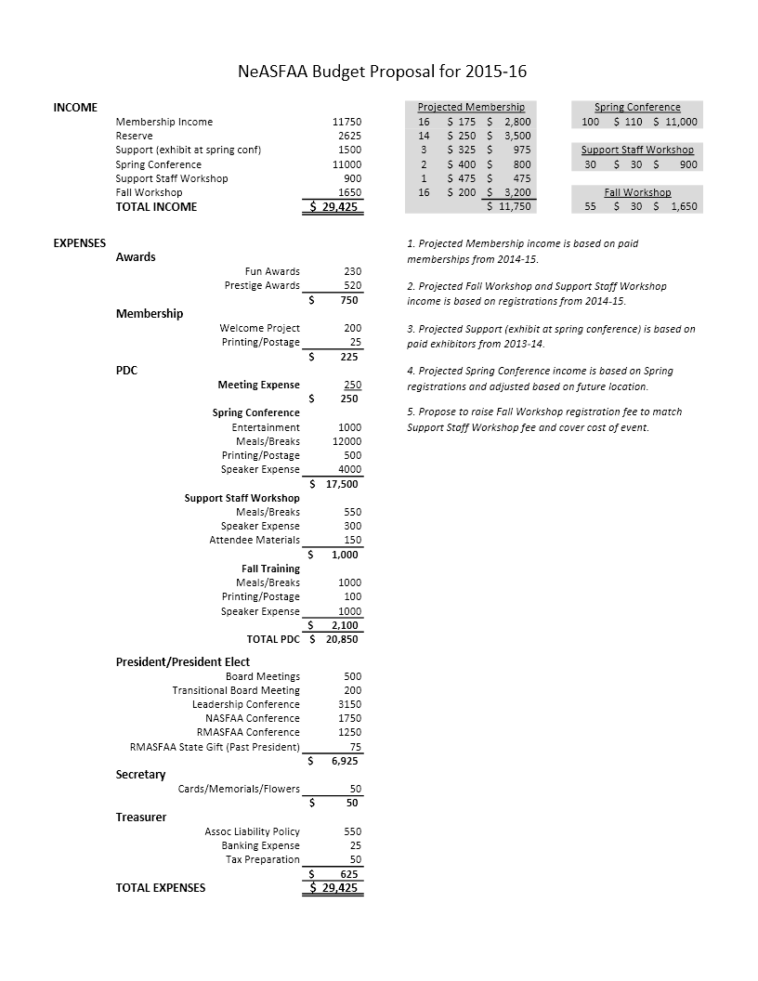

**Annual President’s Report – NeASFAA Business Meeting April 2015**

First of all, I want to thank the association for this opportunity to serve in this capacity as president. Like I put in my last Board Report, I have learned a lot about associations, the people who volunteer for them and about myself. For this reason, I want to endorse especially to the younger NeASFAA members that, you make time, you take time, to serve in a professional association; NeASFAA or the like. We all like to point out how busy we are and the time constraints we are under. However, it is also true that we make time for those things that we consider important. The problem is that sometimes it is hard to find or see the importance in something until you get involved with it. It is easy to pass up opportunity when we do not see the value immediately. A person has to take a risk or have some faith in those that have gone before, because you may have to invest yourself in the organization, before you see the importance. So take a risk, have some faith in me when I say, there is value. Volunteer for a board or committee position. I believe you will be glad you did. Now off the soapbox before someone pushes me off.

This year the board adopted a Conflict of Interest Statement that has been signed by all of the board members and committee chairs. This was one of the strategic directions assigned to me as president to research and recommend an outline and an approach for implementing a Conflict of Interest policy. I developed my recommendation based on research of several of our sister organizations statements and policies. The board considered my proposals, suggested some changes and asked that I let the association review the document. Members of the association that responded to the request for feedback were positive. The board voted on and approved the current policy and document. All future boards and committee chairs will need to sign the Conflict of Interest Policy as a matter of some of the first business conducted each year.

Based on some suggestion during last year’s conference, the board explored setting up a task force to monitor and have a voice in Nebraska Legislative issues that were being proposed in the legislature. This was a significant undertaking. In NeASFAAs recent history, we have not had an organized emphasis that addressed legislative issues on the federal or state level. Legislative advocacy, which is a point listed in NeASFAA’s mission, has only been fulfilled in that we send folks to the NASFAA Leadership Conference where some advocacy is done. For this reason, I have been especially proud of NeASFAA and the Nebraska Legislative Task Force that has been instituted to address issues in the Nebraska Legislature this year. As an association, you saw the charter that was drafted for them to fulfil. It was quite ambitious, and this group has done a great job of trying to achieve all of the objectives set forth in the document. This initiative was initially chaired by Craig Munier, but with his retirement from UNL, Stacy Dieckman assumed the chair duties. Both of these individuals are to be congratulated for the leadership shown in carrying the mission of this task force forward. The task force has monitored the issues in the legislature and members of the committee have either testified themselves or had me testify before the education committee. I hope that as you learn more at this conference about these efforts, that you will be filled with pride as an association at these accomplishments. Future boards will have to evaluate the continuance of and need for future initiatives of this nature. I believe this year’s was a success.

One of my initiatives as president was to change the way we do business with regard to our committee structure. Because standing committees have been a prescribed by our bylaws, making these changes require a significant change to the bylaws. You should all be aware of what is being changed the bylaws based on my earlier communications. I want to highlight again why this is important. There are two basic areas that this change is meant to address – flexibility and volunteerism.

In the realm of flexibility, this change will allow future boards to more readily address the needs of the association as reflected in the committee structure. The more immediate changes will be in the combining Membership and Communications into one committee based on the changes demographically and electronically within the association and also with the PDC and awards committees to streamline awards and programing. I have said several times to the board that the purpose of the Bylaws should be to outline and describe the function of the association without being so prescriptive as to limit the ability of the board to efficiently conduct the business of the association. With regard to volunteerism, my hope is that the new structure will reduce slightly the need for more volunteers, but more importantly, that the volunteers we have will be able to participate more effectively on the committees they serve on, and in turn find more value in the experience.

Lastly, I want to encourage the association and future boards to continue to engage in the process of setting up strategic directions. This exercise drove some of what we did this year as a board and as committees especially PDC and the innovation you have seen in some of the fall trainings and the conference over the last couple of years. I want to thank all those who have participated in the process of devising this document and carrying out the initiatives. The document helped us foster some innovation, guided some of our initiatives and just in general forces us out of the business as usual model just a little bit. The business as usual model can cause an association to wilt on the vine. This does not mean we need to change our mission, but we do need to constantly monitor the effectiveness of what we do to carry out the mission. The strategic directions help us do that. It can be a difficult but also a rewarding exercise and can reenergize some of the functions of an organization.

Thank You all again.

Blessings.

Matt Johnson

NeASFAA President

April 16, 2015

President-Elect Year-End Report – Kay Dinkelman

NeASFAA Annual Business Meeting

|  |
| --- |
| Last April, I received the volunteer forms from the conference (and forms that were emailed!) and put together the committees that have served NeASFAA this year. I want to thank all the volunteers and especially everyone who agree to be co-chairs!  2014-2015 Committees and members were:    Beth Sisk and I attended the NASFAA Leadership Conference (the Association Management Pathways track) in Washington, DC, March 1 – 3, 2015. We scheduled two ‘hill visits’. We were able to meet with a senior staffer in Congressman Fortenberry’s office, who is on the House Committee on Appropriations (no other Nebraska members of Congress are on an education or appropriations/budget committee).  We also met with a staffer in Senator Sasse’s office. I selected Senator Sasse because he is new and I believed it would be good to introduce our organization and explain our availability as a resource for his office. This staffer was interested in what we had to say and had some great questions.  We discussed the need for the Federal Pell Grant and continued support. Neither staffer thought there was any chance for the continuation of the Perkins Loan program.  Thank you to the association for providing the opportunity to attend this conference – it is extremely worthwhile! |

**Treasurer’s Report**

**NeASFAA Annual Business Meeting**

**April 2015**

Submitted by Marty Habrock, Treasurer

**Item 1)** Review of (4) NeASFAA’s CDs with current values:



**Item 2)** Profit & Loss Statements and Balance Sheet

**Item 3)** The checking account balance is healthy and no reserves have been used to supplement the budget in the last 4 years.

* Total income for 2014-15 collected to date is $21,680. As of 4/13/15, need to collect additional $1,210 in Spring Conference registrations.
* Total expenses for 2014-15 paid to date is $8,718.56. However, the majority of Spring Conference expenses are yet to be paid.
* Depending on actual Spring Conference expenses, may have to tap reserves for 2014-2015 in the amount of $2,500 - $3,000.

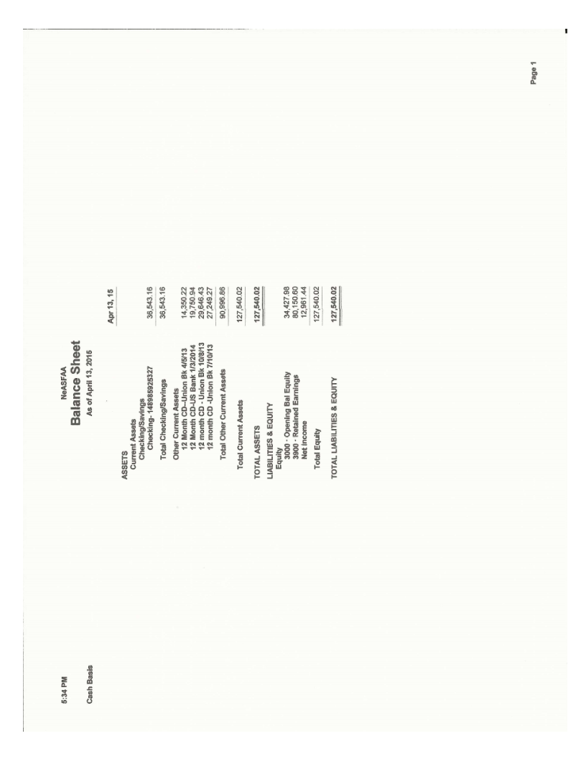

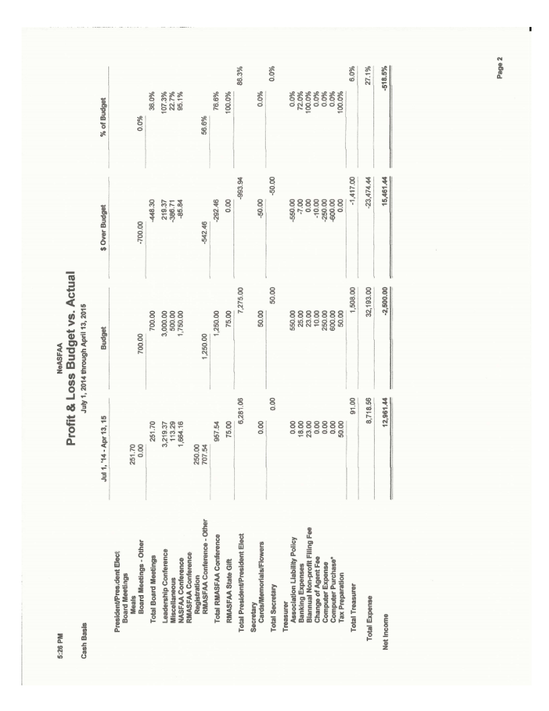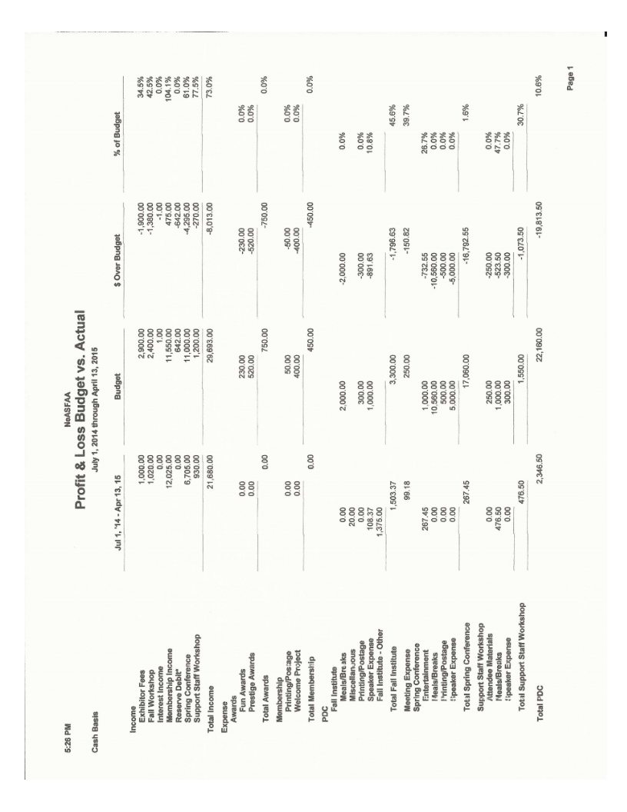

**Secretary’s Annual Report**

April 2015

I attended each meeting and took minutes. A few “meetings” were held via email and minutes were composed for those instances. All minutes were compiled with reports attached and posted on the NeASFAA website.

Respectfully submitted,

Bailey Jorgensen

**Historian Report – J. Ritchie Morrow**

April Board of Directors Meeting

Thanks to Kay Dinkelman and her staff at UNL 6 boxes of historic NeASFAA documents have been scanned and are now stored on a portable harddrive.

On a side note – at Matt’s request I am serving as NeASFAA’s representative on Nebraska’s *Apply2College* campaign, an initiative in conjuction with the American Council of Education’s American College Application Campaign. Eric Drumheller and Les Monroe of EducationQuest are serving as co-chairs of the committee which also includes a number of college admissions representatives and high school counselors. The idea of *Apply2College* is for high schools to set aside one day in the fall to get students to focus on applying to a college and/or to start investigating career options. In the fall of 2014 we had six high schools participate in a pilot project which was quite successful. For 2015 our goal is to sign up 75 high schools to schedule a day between October 19-30. High schools may contact college represetatives and ask for assistance with the day. If this is something you might be interested in please let me know and as high schools sign up we can put you in touch with a high school in your area.

**Two-year Public Sector Report**

The Community College Sector will be taking advantage of the time set aside for the sector meeting at the NeASFAA Conference and will be discussing the following suggested agenda items:

1. no agenda items submitted
2. Davis Chambers Scholarship review of applicants will occur after the conclusion of the conference on Friday

My term as sector rep is ending and Sheila Johns, Western Nebraska Community College, will assume the Public 2 Year Sector Representative position for the next two years.

Respectfully submitted:

Stacy Dieckman

NeASFAA Association

**Private Colleges and Universities Sector Representative Annual Report**

Attended NeASFAA Board Meeting at Central Community College, Grand Island, on June 6, 2014.

Hosted NeASFAA Board Meeting at Concordia University, Seward, on November 21, 2014.

Attended NeASFAA Board Meeting at Nebraska Wesleyan, Lincoln, on February 20, 2015.

Participated in Awards Committee Conference Call on March 17, 2015.

Respectfully submitted,

Wendy Matulka

Private Colleges and Universities Sector Representative

**Professional Development Committee**

**April 15, 2015**

**Summary of Training Activities for 2014-2015 Year**

*Fall Training on Enrollment Reporting/National Clearinghouse* -- conducted at Southeast Community College Jack J. Huck Continuing Education Center –

Attendees: 55

Speakers: Denise Ellis, Registrar Doane College

Robert Haushalter, National Clearinghouse

*Support Professionals Workshop* – conducted at Doane College

Attendees: 28

Topics Included: SULA, Working and Playing Well with Others, Speed Dating Financial Aid Style and a panel discussion regarding the changing roles of support professionals in financial aid offices.

*Spring Conference – NeASFAA the Next Generation* Kearney Nebraska Holiday Day Inn

Attendees: 70 (anticipated)

Speakers: Justin Draeger, NASFAA CEO and Clay Anderson NASA Astronaut

Philanthropy: Bright Futures Pre-School program in Kearney Public Schools

What did we learn this year and what would be some of our recommendations for the upcoming year:

1. We are excited to merge the awards and PDC committees into the Professional Development and Recognition Committee. Integrating celebrations throughout all of our training initiatives is an important part of building community among our members.

2. Some of the issues surrounding SULA remain to be relatively major concerns for our members. We probably left the fall training with more questions than answers. So going forward this would be a likely training topic that will continue to be our agendas.

3. Effective communication within our offices and with our students and campus colleagues also continues to be a thread of conversation and a topic that we tried to address in our training. This also may be something that continues to show up on agendas.

4. PDC needs to remain nimble to be able to act quickly to develop training if a hot topic arises. Given that we may be going into a year where reauthorization may happen, PDC leadership needs to be in tune and prepared to develop some training

5. PDC members and the NeASFAA Board need to be thinking about developing the right training at the right time in the right way. We discussed this year re-working the support professionals’ workshop to be something different than it has been historically. This is because many of our offices are seeing real changes in the “lines” that define professional positions and those in support positions. It may be appropriate that our fall training is re-invented as a result.

I have enjoyed the PDC team this year and want to compliment this committee for their enthusiasm and efficiency and creativity.

They are:

Sara Nordquist Davis

Beth Sisk

Tom Ramaeker

Carol Swenson

Becca Dobry

Jodi Vandenberge

Gloria Hennig

Angie Pinkerman

Marron Keady

Kent Wolfe

Kay Dinkelman

Peggy Tvrdy – Vice Chair

Respectfully Submitted,   
Mary Sommers

April 16, 2015

|  |
| --- |
| Nominations & Elections Year-End Report – Kay Dinkelman  NeASFAA Annual Business Meeting |
| I was able to put together a full slate of nominations - we had some great people running for office this year. Here are the results.  2 year public sector:  Sheila Johns- Western Nebraska Community College  4 year public sector:  Becca Dobry- University of Nebraska at Kearney  Secretary:  Stacy Dieckman- Northeast Community College  President – elect:  Beth Sisk- College of Saint Mary  I would like to thank everyone who agreed to run on the ballot for their willingness to serve the organization! |

**Membership Committee Business Meeting Report**

**April 2015**

The Membership Committee had a busy year. There were two initiatives from the President and Board that required our attention.

The first project was developing a proposal to the Board on how to combine the Communication Committee and the Membership Committee. Linda Butcher, Chair of Communications, and I met to develop three options that were presented at the Fall Board Meeting.

The second project was adding information to the current membership directory. The Board wanted to know a few more items that were not currently available in the old format. The communications committee contacted our membership and got updated information for us to add to the PDF that is on the NeASFAA website. The new information includes the voting members and if your institution or office has any social media presence.

As with any year, the committee sent out Membership Renewal notices and updated the directory as changes were reported. We ended the year with 36 Institutional Members and 16 Associate Members.

Respectively Submitted

Shareen Thewke

**Finance and Audit Committee Annual Report**

The Finance and Audit Committee conducted the NeASFAA annual audit for the 2013-14 fiscal year on August 8, 2014. The committee concluded that NeASFAA is financially healthy and the responsibilities of the Treasurer are being conducted properly.

Our committee made a recommendation to the Board to add the recently updated Audit Guide to the appendix of the NeASFAA Policies and Procedures. This will help ensure that everyone has access to the correct Audit Guide. The Board approved the recommendation at the February 2015 meeting.

Budget requests were sent out in February for the 2015-16 fiscal year. The budget was completed March 13 and is ready for membership approval.

I would like to thank all the members of the Finance and Audit Committee for your help this year!

Hylee Asche, Chair

**Corporate Development Committee**

Stacy Seim – EducationQuest Foundation

Kent Wolfe - Inceptia

* The 2014-15 NeASFAA membership/pledge form was emailed to approximately 74 organizations in June 2014.
* 13 associate organizations are listed as members for the 2014-2015 year
* Selected the Bright Futures Program as the Philanthropy organization for Spring Conference

I do not have an annual report for the Associate Sector.

Respectfully submitted

Stacy Seim

Corporate Development Chair and Associate Member Sector Representative

**Communications Committee Annual Report**

**Membership Directory**

In response to increased security concerns, the membership directory in NeASFAA.org has been password-protected. The instructions to access the membership directory are:

Go to NeASFAA.org

If the membership directory is not visible under Quicklinks along the right side of the page, click

on Quicklinks.

Click on Membership Directory under Quicklinks.

The Sign In page appears. Enter the generic username and password:

  Username: [member@neasfaa.org](mailto:member@neasfaa.org)

   Password:  nebraska

Click Sign in.

Click on Membership Directory.

**Survey**

A survey of NeASFAA members was conducted in October 2014 to measure how well NeASFAA is meeting the electronic needs of its members. 49 people completed the survey.

98% (48) of respondents have accessed NeASFAA.org. The top two reasons in accessing the website were to access the membership directory and to access event information (including conference materials and event registration.) Other reasons included Board and committee information; pictures; P&P, By-laws, and meeting minutes; FA community news; and general information. The lone respondent who has not accessed NeASFAA.org did not provide a reason why he or she has not accessed the website.

10% (5) of respondents have accessed NeASFAA.org from a mobile device. The top two reasons to access the website from a mobile device are to access P&P and By-laws and to access the membership directory. Other reasons included “was out and about at meetings- conference” and “didn’t have a computer available.”

43% (21) of respondents have joined the Friends of NeASFAA group on Facebook. 59% (29) of respondents would like to be able to pay membership, conference, and training fees online with a debit or credit card. 86% (42) of respondents think NeASFAA should offer training and board meetings via teleconference.

When asked how NeASFAA can better serve their electronic needs, the comments included:

Ability to pay for activities online with a credit/debit card

Fix issues with the listerv – trouble accessing listerv in order to post something, listserv emails are not received

Keep the website relevant and up to date

Live streaming/teleconferencing of training/board meetings.

Lastly, one member asked to join the NeASFAA listerv.

**NeASFAA listserv**

There is no moderation on the list, however only members/those on the list can send to the list. Members can request to be added to or removed from the listserv in the Resources section of the NeASFAA website. The Communications Committee can also be contacted to add or remove a member. The Communications Committee will then contact Lisa Boatman at FES/SOCS.

If someone is not receiving emails from the listserv, the Communications Committee can check with Lisa Boatman to verify that the person and the correct email are on the list. If the person’s correct email is on the list, the person should check his or her spam folder and check with the school’s IT people as perhaps there is a firewall issue.

**NeASFAA Volunteer Form**

The NeASFAA Volunteer form is now available in an electronic format on the NeASFAA website. Members can complete and submit the form electronically through the website. The Word version of the form is still available on the website for those who prefer to print, complete, and mail the form.

**Cloud Storage/File Sharing**

The NeASFAA Board of Directors and committee chairs are now using Dropbox Basic for individuals to store and share working documents. Each Board member creates his or her own Dropbox Basic account and shares documents as needed with other Board members.

**Archiving Documents**

Archived NeASFAA documents can be stored on the NeASFAA website in a private section that is password-protected and not visible to the public.